Project Title: WineSnob

Team Members

* Lisa Hagin, Martin Ade, Caroline Dougherty, Andrew Schnarre

Project Description

An app targeted for inexperienced wine buyers that allows photo input of the wine list and return a selection based on reviews, tasting notes, and ratings.

The returned selection is prioritized based on user input criteria. Geolocation could tell you based on where you are where to go buy it.

The user could save wines tried in a favorites list and to rate them on a scale from 1-10

Sketch of Final Product

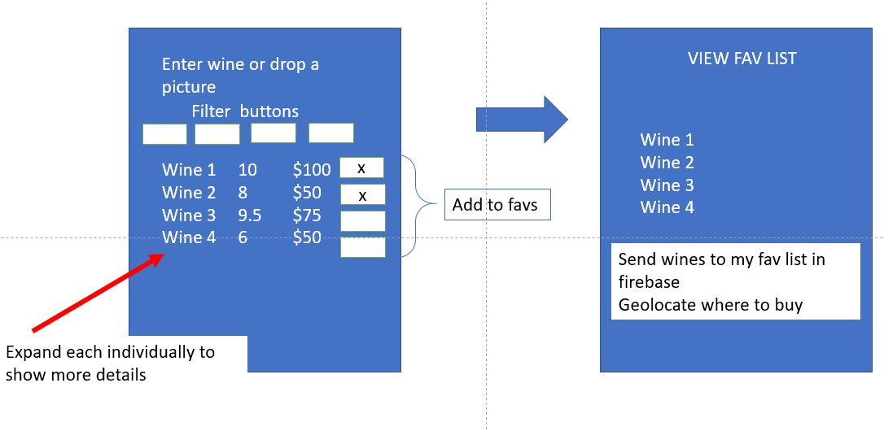

APIs to be used

* API.wine.com – for wine information
* Geolocation – for winery location and nearest location to purchase
* Firebase – to hold my favorites and rate per my liking

Rough Breakdown of Tasks

* Get API keys access for WINE information & GEOLOCATION for position relative to winery
* FIREBASE for our favorites – Setup firebase
* Define github repo and invitations - DONE
* Assign repo master for pulls – DONE
* Decide responsive technology for html – Semantic, Flex, Materalize - SEMANTIC DONE
* Major coding tasks:
  + API - can we use it – get the keys (WINE and GEOLOCATION)
    - Make the call what info we can get (Caroline, Andrew, Lisa)
  + Photo to text recognition
  + Martin to setup FIREBASE
  + HTML Design
    - Andrew and Caroline
    - Develop common naming convention for IDs
  + JS Development
    - Lisa and Martin
  + Learn how to branch and to merge
  + Testing
* Define demo presenter and demo goals

Workflow steps

1. Take PIC of the list
2. Crop to a limited set to search
3. Create list internally
4. Take the name and compare in API
5. bring back data we want and populate table
6. table has a favorite star on the left and a delete on the right
7. user with click the FAV button to push to firebase
8. if table is refreshed all goes away except for items selected as a fav
9. on the fav list click to show closest liquor store